How do Digital Signatures work?
Digital Signatures are a clever approach of using complex mathematics in real life work
Let‘s see how it works…

Setup Step 1 : Genererate your own key
First you create a Key pair containing a Public Key and a Secret Key.

The access to your Secret Key is protected by a passphrase

Setup Step 2 : Distribute your Public Key
Distribute your Public Key to other users
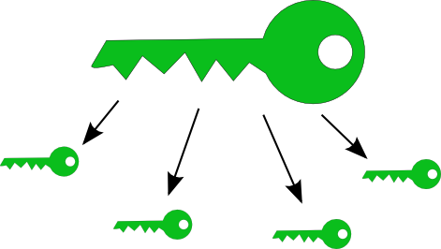

Maintenance: Store received keys
The users add received Public Keys to their Public Key Ring


Maintenance: Verify received Keys
The other users verify your Public Key with your Key Certificate

If it matches, they sign your key as valid

Creating a Digital Signature
To sign a file, first the checksum of the file is calculated
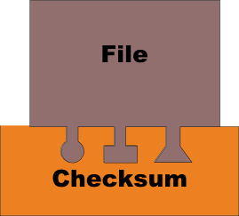
Then you create a Signature out of your Secret Key and the file checksum
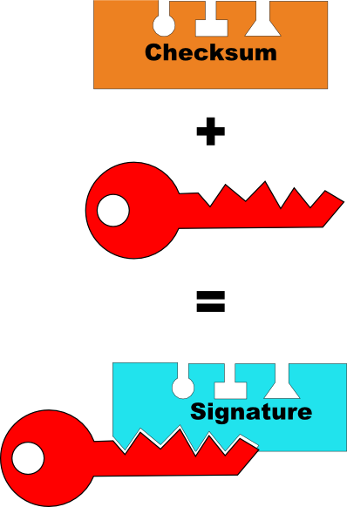

Distributing a Digital Signature
Distribute the Signature to whoever needs it
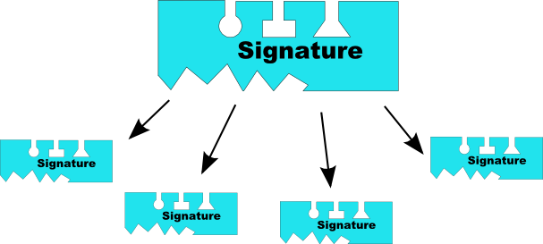

Verifying a Digital Signature
The other users validate the Signature by compare it to the file checksum of their local file and your Public Key stored in their Public Keyring
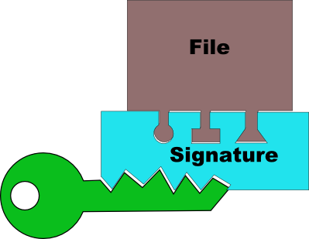
Only if both matches, the Signature is valid

