News

10 June 2009 SKDS 4.0 is now FreeWare
To bridge the time between the old, licence bundled SKDS 3.0 and its successor, SKDS 4.0 has now been released as freeware with unlimited functionality for everyone.
It 4.0 the dongle mechanism has been replaced against a public key system to keep the security of the script files without the need of a hardware dongle.
SKDS 4.0 is available now on the download page.

10 June 2009 OpenSource Project started
To maintain the redesign of SKDS as OpenSource software, a new project page has been setup on SourceForge
www.oobd.org
There you can follow up all activities or even join the development team to bring in your own ideas and knowledge

8. Sep. 2007 SKDS 3.0 successfully passed Wordwide Remote Test

On the 7. September 07 SKDS successfully passed the state-of-the-art remote diagnostic test where the tested vehicle and the tester where located on the both different ends of the eurasian continent
A car was connected though a Laptop running SKDS and Skype and a slow GPRS mobile phone data link to the internet in europe, while the tester was located behind a company firewall in china.
Despite the slow connection, the firewall and the distance of around 8000km, both systems connected instandly to each other and SKDS was working as if the tester was sitting directly inside the car.
This test approves finally the right decision to use Skype as a data carrier for Diagnostics messages, which makes SKDS to a unique diagnostic tool indepentend from locations and distances.

3. Apr. 2007 SKDS 3.0 in Public Beta Testing

Automotive Industry first: SKDS 3.0 offers a true remote Diagnostics functionality. It uses Skype Software (VoIP) to connect to a vehicle located whereever in the world for diagnostic trouble shooting from an engineering desk.
This saves time, travel expenses and brings engineering expertise to whereever it is needed.
To join the public beta testing of SKDS 3.0, please contact beta@skds.de for more details
The new SKDS release 3.0 incorperates
- Library functionallity: integrated Database for DTCs - ok, nice to have…
- UDS- Protocol with new script commands for easy and quick data exchange without the need to play with each single telegram - hmm, sounds better…
But the smash hit of this release is the
Skype connectivity:
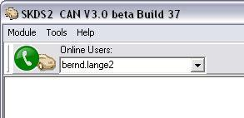
Connect yourself with a single mouseclick to another SKDS/Skype- user anywhere in the world and conduct vehicle diagnostics remotely on his vehicle as if you would sit directly in the car:
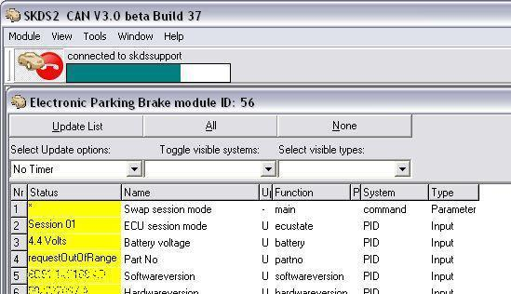
Portable:
In the manual you'll find of how to set up SKDS and Skype to run e.g. from a memory stick without any installation, so that such a pack can be e.g. downloaded, unpacked and started whereever needed.
The only software which needs to be on the remote maschine is a CANbus hardware from Vector Informatik.

