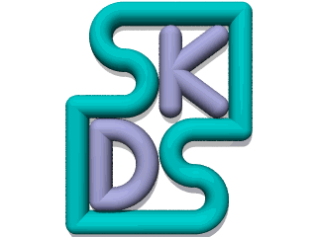

Welcome to SKDS
SKDS is a unique tool to diagnose all Vehicle Electronic Control Modules (ECUs)
SKDS Classic is connected via a serial voltage converter directly to the ISO9141 K- Line
SKDS CAN uses a CANCard or a CANCase to communicate to the ISO11898-2 CANBus
SKDS can be adjusted by its script language to any Electronic Control Module (ECU) in protoype vehicles

The Advantages of SKDS
The SKDS Script language is used to react very flexibly on new diagnostic specifications and ECU software updates.

SKDS - A Unique Window into the Vehicle Diagnostics World
- SKDS is free
- The Skript files and their usage is protected by a RSA Public Key System
- Genereration of ECU specific SKDS script files
- Observe all diagnostic traffic in a bus tracing window (Bus sniffer)
- New: Remote Diagnostics between two SKDS users via Skype (VoIP)
SKDS is Copyright 1998-2010 by Steffen Köhler; all other trademarks are the property of their respective owners. Steffen Köhler denies any responsibility for any errors that may appear in these pages. Information contained herein is subject to change without notice.
CANCard and CANCase are registered Trademarks of Vector Informatik GmbH
Skype is a registered Trademarks of Skype

