Introduction
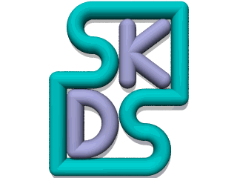

Welcome to SKDS
the effective Prototype Diagnostics Tool.

Sidemap
If you just want to use it, see Quick Start and Main Window.
If you have already worked with SKDS Classic before, you will find the differences between the classic and the CAN versions in the chapter Version-Differences.
If you also want to make your first steps with the build-in programming language to design you own scripts, start with the introduction in the SKDS Script.
You will find how the files are protected against unauthorised reading or execution in Key-Management.

What is SKDS?
SKDS is the interface between the user and the data hidden behind the surface. It allows the user to fully control the module without needing to know any of the protocol details.

How does SKDS work?
- All the necessary steps to execute the requested function will be defined once by the programmer in the internal pascal-like programming language
- Then during normal usage all functions can be picked instantly from the list in the main window.

What are the features of SKDS?
- Freeware (from Version 4.0 onwards)
- Remote Diagnostics: Two instances of SKDS can be coupled via Skype ® to do diagnostics over the internet
- Multi-Module-Mode: Several modules can be controlled at the same time;
- Full Script Control: All functions are exchangable through external script files;
- Autoload: File names given in the command line at the program start automatically get loaded and started;
- Autorun: If the script contains a procedure called 'Autorun', this procedure is automatically started when loading the script;
- Readable Scripts: Because the module-scripts are written in a human readable programming language, this information can be printed, faxed and archived;
- Function-Library: Because of the readable format, already existing functions can be re-used as a basis for further development;
- Integrated Bus-Indicator: An external LED on the hardware is not necessary as SKDS adds a symbol to the taskbar which flashes with each incoming or outgoing telegramm;
- Scanner: SKDS can scan the complete vehicle Bus for connected Modules and identify these Modules;
- The script files show their author and their generation date. They are encrypted and protected against modifications.

