SKDS Pack Content
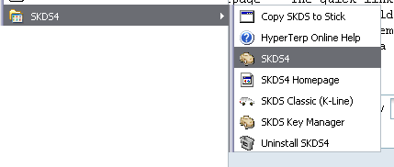
SKDS comes with several tools, which are accessible from the SKDS-Menu on your program start bar.
These tools are:
- Copy SKDS to Stick This allows all required files to be copied e.g. onto a memory stick to always have SKDS available in your pocket.
- Hyperterp Online Help The documentation of the build-in script language of SKDS
- SKDS3 The main program.
- SKDS Homepage The quick link to the SKDS-Homepage.
- SKDS Classic (K-Line) An older version of SKDS, partly updated, to work with modules which are connected via a serial link (K-Line).
- Uninstall SKDS4 This will remove the SKDS installation again from your disk.
- SKDS Key Manager The tool to generate your personal key set and to translate encrypted script files to other users

